Thinking Through Your Activities

Make Category Lists
- Spiritual Development
- Household Tasks – weekly
- Household Tasks – monthly
- Outdoor Tasks
- Weekly External-facing Activities
- Weekly Internal-facing Activities
- House Projects
- Social Friends & Extended Family
- Family Fun Activities
- Hobbies
- Special Treats

Make Priority Lists
- Have to Do
- Need to Do
- Want to Do
- Would Like to Do

Example Category List: 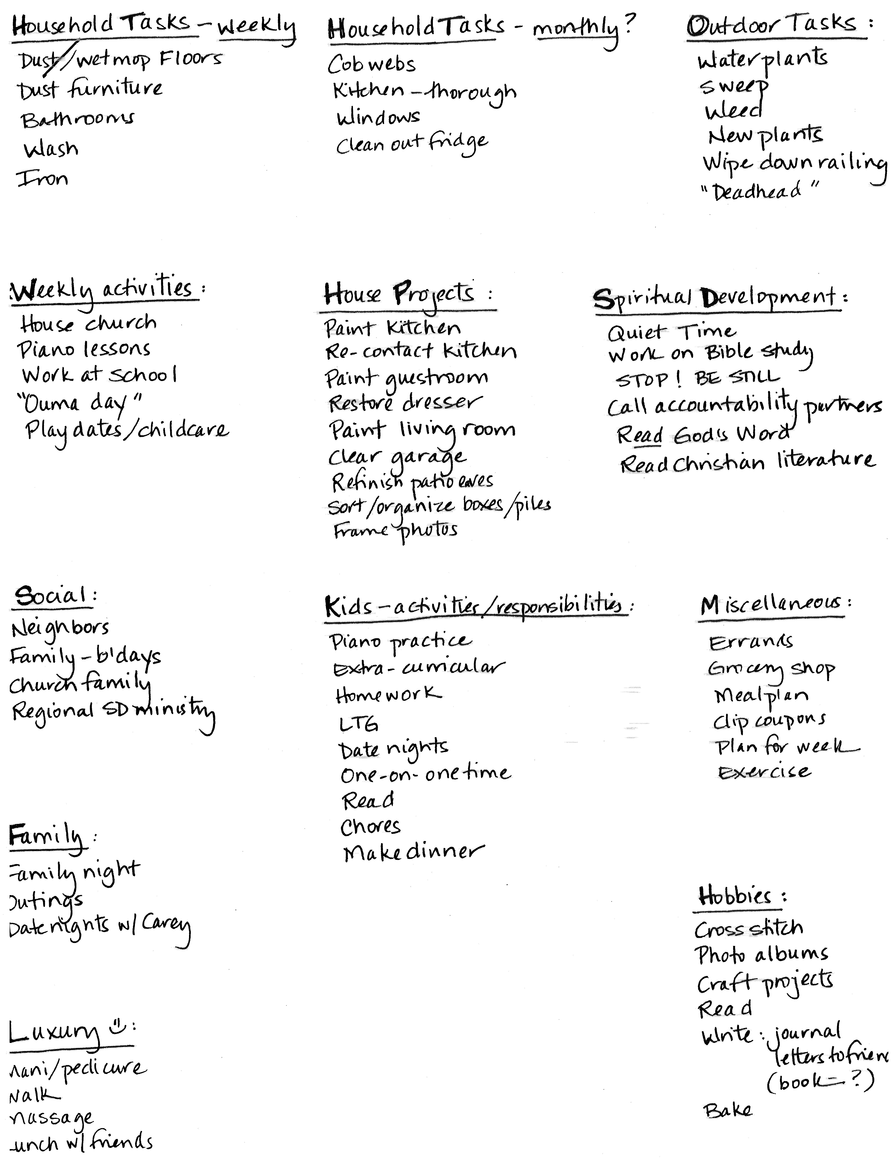

Example Priority List: 